**The Ethical Cycle**

Table of Contents

Moral Problem Statement 3

Problem Analysis 4

Options for Action 5

Ethical Evaluation 6

Reflection 7

By this point, it should be abundantly obvious that there is no fixed way to evaluate right and wrong and that everything depends on the situation. The ethical theories we have studied can only help guide us at best. We still need to evaluate every situation ourselves and take the right decisions. This is where the ethical cycle comes in.

The ethical cycle is a systematic approach to dealing with morals problems. Here, we are trying to look at moral problems as though they were design problems. Moral problems tend to be ill-structured, demanding that we satisfy different, often conflicting, moral constraints. They do not usually have a single best solution, requiring both analysis and creativity.

The ethical cycle consists of five steps:

* Moral Problem Statement
* Problem Analysis
* Options for Action
* Ethical Evaluation
* Reflection

## Moral Problem Statement

This is the question that states the moral problem. We need to take into consideration what the problem is, and who needs to take action.

For example, say someone misses an exam due to health issues, but, according to the rule book, they were supposed to inform their teachers about the problem they were facing at the time, which they did not. Should the teacher still allow them to give a make-up exam?

We also need to take into account the morality of the situation. What morals are being questioned in this scenario?

## Problem Analysis

We need to consider three things while analysing the problem.

Firstly, we have the interests of the stakeholders. In this case, the stakeholders include the student and the instructor. The effect on the first is obvious, while the latter may have their honesty, integrity or reliability depend on what decision they make.

Secondly, we need to consider the values of the situation. Here, we need to be looking at the values the rules exist to uphold.

Finally, we need to be looking at the facts.

## Options for Action

There are two options here, either allow the student to attend the exam, or do not allow them. If we look at the situation purely in terms of these two options, then it falls into something called the Black and White Strategy, which assumes that there are only two possible options that are opposites of each other.

Another strategy could be the Co-Operation Strategy, which in this case would involve both parties trying to help each other, perhaps to ensure that the make-up exam can be held as early as possible so as to avoid disparities between the results.

## Ethical Evaluation

Now we can begin evaluating the options available to us using the different ethical theories that we have studied. The Kantian theory would forbid any make-up exam due to the fact that the student failed to inform the teacher earlier, the utilitarian theory would perhaps encourage the make-up exam be allowed, given that other students are not displeased about this, and virtue ethics would point out the problem with partiality being shown, though it may allow the make-up exam with some penalty, such as time or marks, since that would show kindness. Additionally, we also take into account what our intuition and common sense tells us, plus any codes of conduct we are required to follow.

## Reflection

Essentially, we look at what the different results of the evaluation phase are and finally make a well-argued choice about what to do. We need to consider if an ethical framework provides reasons that support our opinion, and if not, if some other reasons do. For other reasons, they also have to be strong enough to override the arguments of the ethical frameworks. We also need to make sure that we are correctly selecting all of the features of the situation that are morally relevant. We may need to revise our opinions and need to consider how to do this.

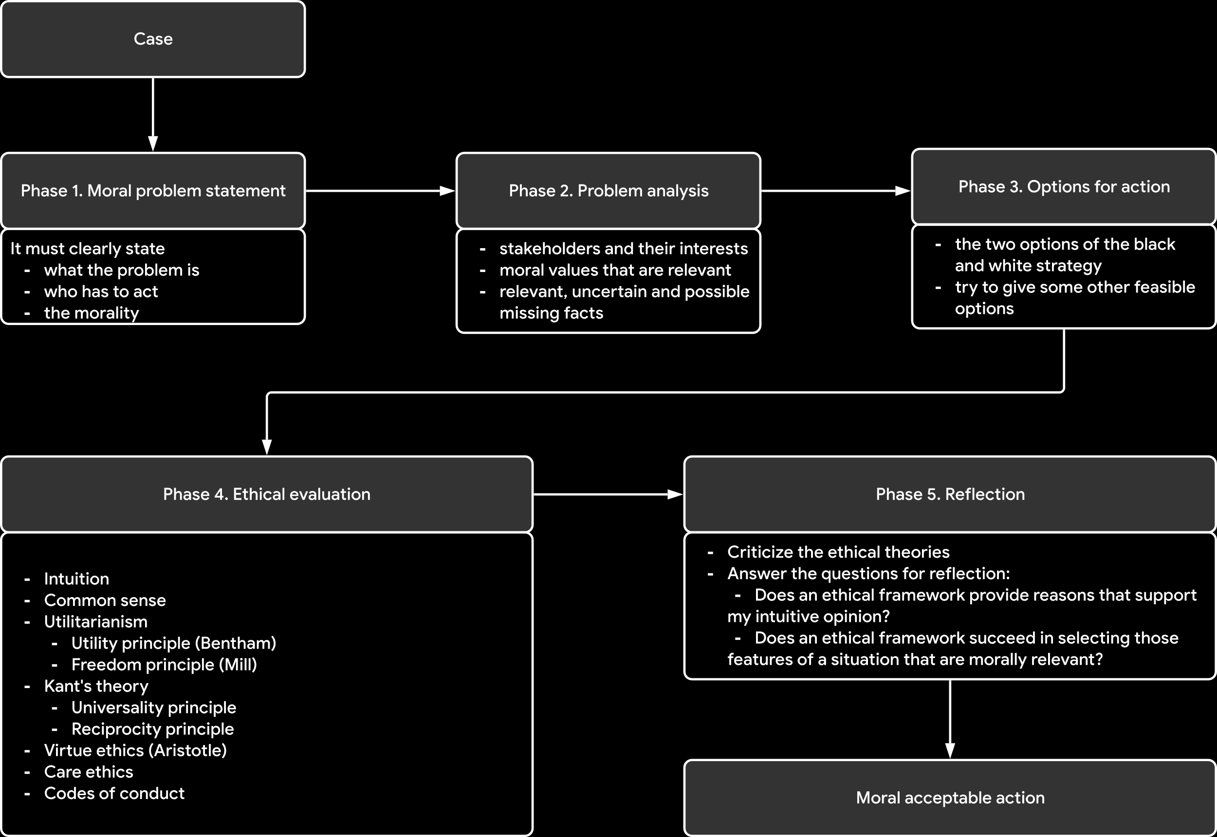

At the end of all of this, we finally reach a morally acceptable decision.